Shop & Smile Superstores Sales Report For The Year 2014

Outline

Introduction

Story of Data

Data Splitting and Preprocessing

Pre-Analysis

Post-Analysis and Insights

Data Visualization and Charts

Recommendations and Observations

Conclusion

References & Appendices

Introduction:
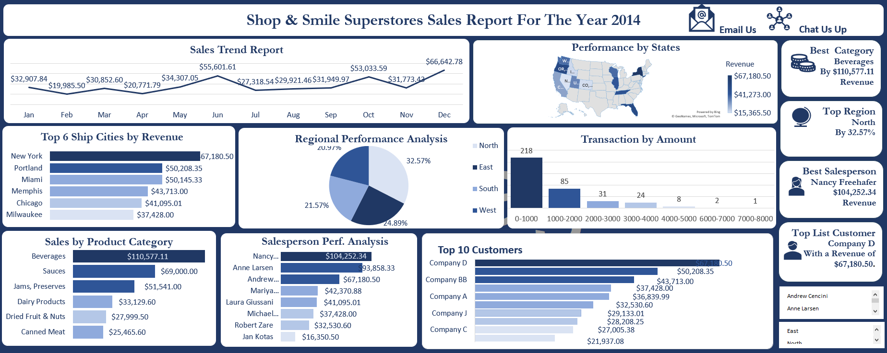

-Project Objective

The major aim and objective for this analysis is to analyze the sales report of Shop & Smile Superstores for the year 2014, and this analysis further aims at helping the stakeholders of this project to make data-driven decisions for the business in the next coming year.

This project aims at addressing and answering these questions:

The Sales Trend Report for the months in the year 2014
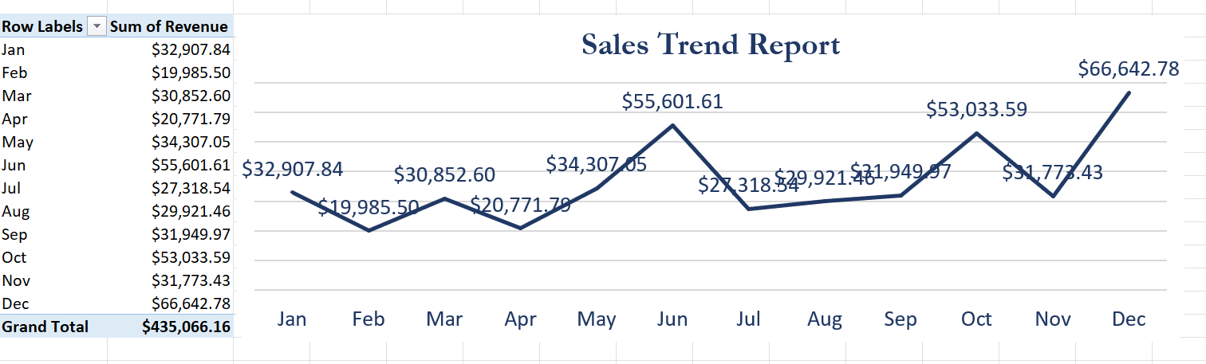
Finetune out Top 10 Customers
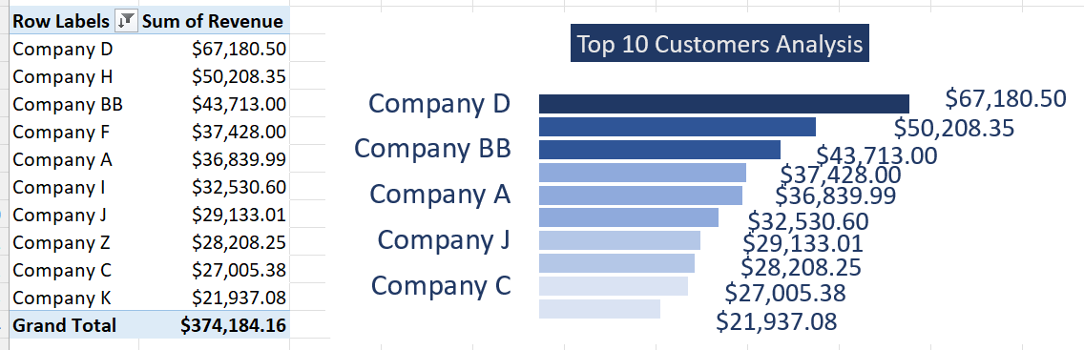

Ascertain the Revenue generated by each Salesperson.
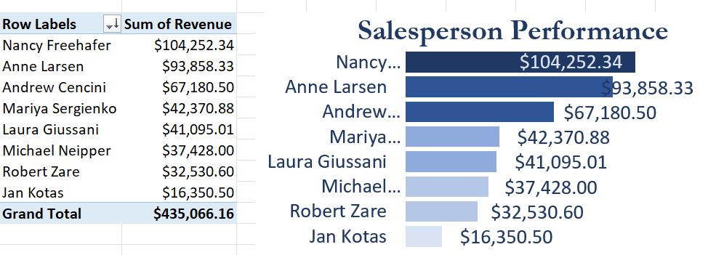

The Revenue generated by each Region.
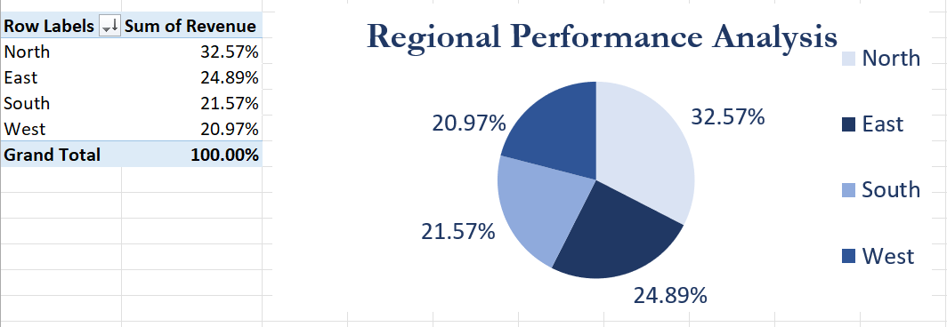

Performance by States
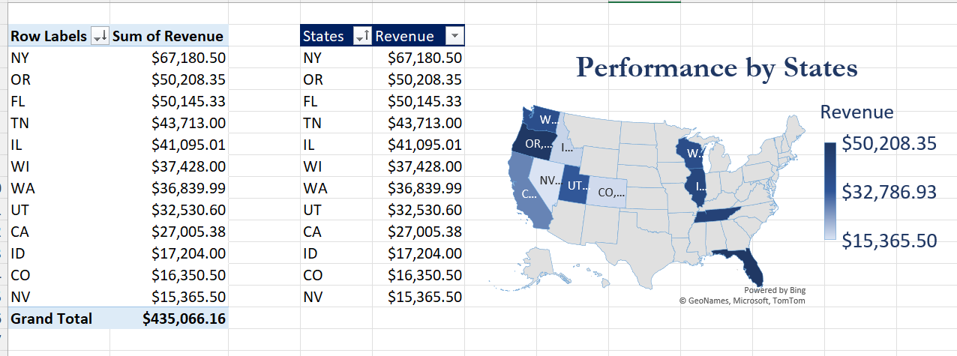

Transaction by Amount
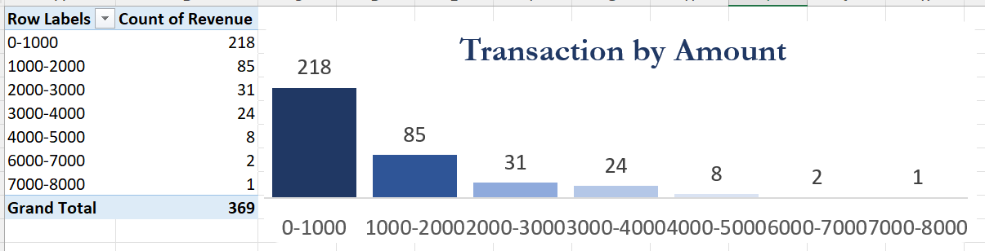

The Revenue from the sales of each Product Category
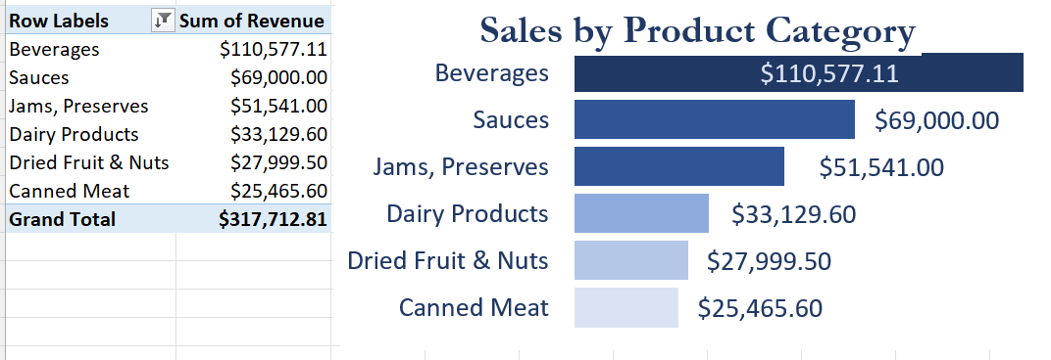

Top 6 Ship Cities
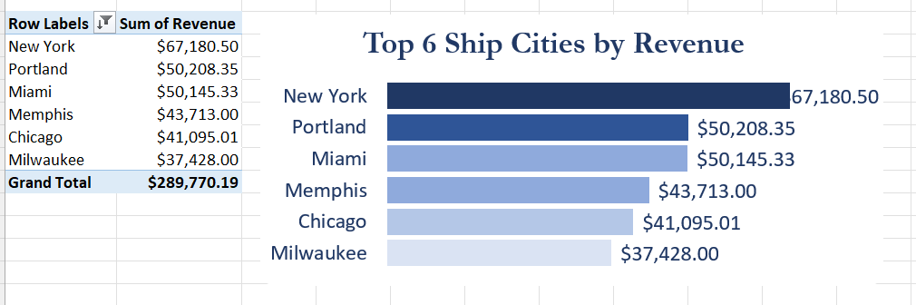

Top Cities by Revenue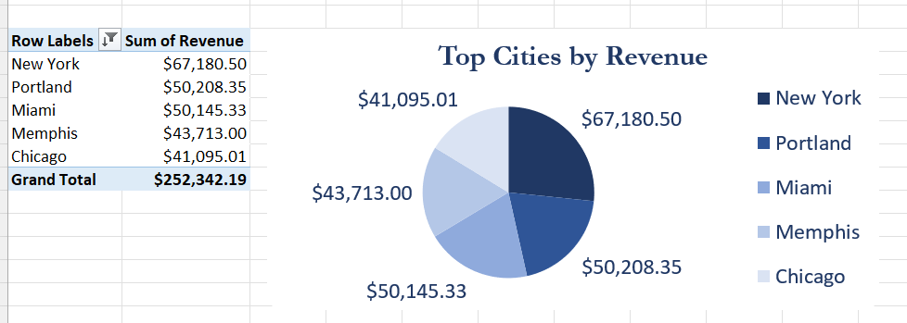

The major dataset used for this analysis is Sales Data. The key methodology used is Microsoft Excel and the Pivot table in Microsoft Excel was the major tool used to address and answer all of the project questions.

Story of Data:
This project is connected to a sales dataset from the Grocery industry and available for public consumption. The dataset was downloaded from kaggle.com and it has a total number of 370 rows and 26 columns.

The dataset is structured in columns and rows. The columns contain variables, both Dependent and Independent Variables. And the rows contain the data points and transactions.
The analysis includes Revenue as the key outcome variable and variables such as Customer Name, Region, Category, City, Salesperson, Quantity and State. These variables contribute immensely to this analysis as they are key factors to addressing and answering questions from the project.
The limitations and biases encountered with the dataset were empty columns, duplicates, inconsistency in letter casing and word spacing.

Data Splitting and Preprocessing

Data cleaning
I got the dataset downloaded from kaggle.com and uploaded it into my Excel Workbook for further analysis. Basic checks and observations were made in the dataset to ensure it was clean and consistent for analysis. Checks for duplicates, empty cells, inconsistencies in letter casing and spacing were made and corrected. To retain the raw dataset for another use, I had to duplicate the dataset and use one for the analysis.

Data Splitting
The dataset was split into two variables namely, Dependent Variables and Independent Variables.

Independent Variables:
1. Customer Name
2. Country
3. Salesperson
4. City
5. Region
6. Ship Name
7. Product Name
8. Category
9. Ship Country
10. Payment Type
11. Shipper Name

Dependent Variables:
1. Revenue
2. Quantity
3. Shipping Fee
4. Unit Price

Industry Context and Stakeholders

The project is for a Grocery Store with Revenue Means. The data is telling a story around goods received from different shipping companies, a breakdown of how the goods were sold by different branches in different countries, it further highlights different quantities purchased, the salespersons in charge of each city and country.
The major stakeholders for this project are the Chief Executives and Marketing Team.
To this industry, generating more revenue while satisfying their customers is exactly what success means to this industry.

Pre- Analysis:

Potential Questions
1. Regional performance by revenue generated
2. Performance analysis of each salesperson by revenue generated
3. Customer performance analysis by quantity purchased
4. Payment usages over time by quantity used per payment
5. Best performing products for the year by quantity purchased
6. Product category performance by revenue
7. Performance analysis for shipping countries with reference to quantity and revenue
8. Product category performance by quantity
9. Salesperson performance by revenue
10. Salesperson performance per region by revenue
11. Best performing shipper name by quantity delivered over time.
12. Performance analysis for shipper name by shipping fee.
13. Best performing ship country and ship name by shipping fee
14. Most affordable product name by unit price
15. Most used payment type by revenue
16. Salesperson performance per city by revenue
17. Product Category performance by unit price
18. Performance analysis for customers per city by quantity purchased.

Potential Insights
1. Finetune out the best region for the year and explore more measures to gain more grounds.
2. Finetune the best performing product and ensure this product never diminishes hence preventing its customers from firm-switching
3. Finetune best performing methodologies used at the top performing region to ensure more revenue means.
4. Finetune out the best payment method most suitable for customers and ensure it's kept on check
5. Ascertain the best and more purchased product and ensure to always get it well stocked up.
6. Ascertain the best performing product category and ensure it maintains the standard.
7. Understand the performance analysis for each shipping country by quantity or revenue and make sure to retain shipping country that generates more revenue to the company
8. Finetune out the best performing product category and ensures it reaches customer satisfaction
9. Using revenue to finetune salesperson performance and encourage them to remain outstanding
10. finetune shipping name with best performance by the quantity of products they deliver and retain them.
11. Ascertain the best performing shipper name by their shipping fee and ensure they are retained.
12. Ascertain the best performing ship country and ship name and maintain good business relationship with them
13. Finetune out the most affordable product name by unit price and ensure their unit price is always fair.
14. Finetune out the most used payment type and ensure it is acceptable in all other locations of the business.
15. Ascertain cities with the best salesperson and ensure they are transferred to locations with low revenue
16. Finetune the best performing product category per city and ensure their unit prices are always fair enough
17. Ascertain the best product category and make sure to maintain it.
18. Finetune performance analysis for best performing customer per city and encourage them to patronize the company more.

Data Visualization:
1. Sales Trend Report
2. Top 10 Customers
3. Salesperson Performance.
4. Regional Performance Analysis
5. Performance by States
6. Transaction by Amount
7. Sales by Product Category
8. Top 6 Ship Cities
9. Top Cities by Revenue

In-Analysis Observations:

ANALYSIS - Top 10 Customers
- Company D ranked first as the best performing customer for the year with a total revenue of $67,180.50.
- Company K has the lowest performance with a poor revenue of $21,937.08.

ANALYSIS - Salesperson Performance
- Nancy Freehafer topped the performance chart for the year by generating $104,252.34 revenue for the year 2014.
- Anne Larsen topped as the second best salesperson by generating $93,858.33 revenue.
- The least performing salesperson is Jan Kotas with a total revenue of $16,350.50 for the year 2014.

ANALYSIS - Sales by Product Category
- Beverages topped other product categories by generating $110,577.11 for the year 2014.
- Canned meat has the lowest sales with a poor revenue of $25,465.60.
- Dried fruit and nuts also didn't have good sales for the year 2014 ,as it generated a poor revenue of $27,999.50.

ANALYSIS - Regional Performance
- The Northern region topped the other regions as the best performing region for the year 2014 by generating 32.57% of revenue.
- The Western region performed poorly for the year with just 20.97% revenue.

ANALYSIS - Sales Trend Report
- The month of December has the highest sales report for the year 2014 with an impressive revenue of $66,642.78.
-The month of February recorded the lowest sales for the year 2014 with a revenue of $19,985.50 only.
-There is a disturbing increase of $55,601.61 and a sharp decline of $27,318.54 in sales between June and July.

ANALYSIS - Transaction By Amount
- The goods that generated the highest counts of sales are goods between the prices of 0 to 1000 with a total of 218 sales count.
- Goods between the prices of 7000 to 8000 have the lowest sales count with just 1 sale count.

ANALYSIS - Performance by States
- New York topped other states as the best performing state with a revenue of $67,180.50 .
- Nevada is the least performing state with a Revenue of $15,365.50.

ANALYSIS - Top 6 Ship Cities by Revenue
- New York city topped the other ship cities with a revenue of $67,180.50 .
- Milwaukee generated the least revenue amongst others with a poor revenue of $37,428.00.

ANALYSIS - Top Cities by Revenue
- New York city has generated an amazing revenue of $67,180.50 above the other cities.
- Portland and Miami have a close reach in their revenues generated. Portland generated $50,208.35 while Miami generated $50,145.33
- Chicago performed poorly with a revenue of $41,095.01.

In-Analysis Insights:

ANALYSIS - Top 10 Customers
- A reward or appreciation program can be put in place to motivate other customers and promote competition among customers.

ANALYSIS - Salesperson Performance
-Nancy Freehafer can be recommended for promotion, thereby boosting her morale to do more.
-Jan Kotas, the least performing salesperson, can be recommended to be suspended , as his inefficiency and zeal for the job affects the company's revenue.

ANALYSIS - Sales by Product Category
- The quantity of beverages for sales should be increased, since it has high demand.
- An investigation as to why canned meat recorded poor sales should be made
- A smaller quantity of dried fruit and nuts should be shipped in, to avoid most of them expiring since it has low demand.

ANALYSIS - Regional Performance
- The methodologies used by the Northern part should be studied and implemented in the Southern and Western regions.
- The Western and Southern region should be audited to finetune the key reason for their low performance.

ANALYSIS - Sales Trend Report
- Variety of goods should be made readily available in the month of December, as revenue is generated more in this month.
-Findings should be made to finetune the factors surrounding poor sales in February and workable measures should be adopted to manage it.
- A quick and timely observation should be made as to ascertain why revenue dropped drastically between June and July.

ANALYSIS - Transaction By Amount
- A price-slash or promo can be placed on the products with lowest sales count to encourage customers.
-The goods with the highest sales count should be readily available to customers to optimize more revenue.

ANALYSIS - Performance by States
- Experienced staff from New York can be transferred to Nevada to help improve the sales and revenue.
- More goods should be shipped to New York since it generates more revenue than the other states.

ANALYSIS - Top 6 Ship Cities by Revenue
- The methodologies used in New York City to generate outstanding revenue should be adopted in Milwaukee and Chicago.
- New York ship city should be given more shipping contracts to encourage them.

ANALYSIS - Top Cities by Revenue
- Rewarding bonuses or benefits should be given to staff in New York to motivate and boost the work morale.
- A competitive scheme can be put in place for Portland and Miami to make them generate more revenues for the company.
-An investigation should be carried out on Chicago to finetune the root causes of their poor revenue generation.

Post-Analysis Observation

1. Nancy Freehafer topped other salespersons. She's from the Northern Region, and her top customers are Company H, Company A and Company G. The products she sold more were beverages, sauces, dairy products, canned meat, candy and baked goods. She also made great sales in June, October and December.
2. Jan Kotas generated the least revenue among other salespersons. He's from the Eastern region, Company CC is his only customer. His highest sales were in June and December. Denver ship city was his best ship city and the products he sold more were beverages, fruits & Veg., and candy.
3. The Southern region recorded huge sales and revenue in the months of June, October, November and December. The ship cities that worked more with the Southern region in 2014 are Miami and Memphis. Company BB, Company Z and Company K patronized the Southern region massively and the major products they bought were beverages, canned meat, sauces, oil, soups, dried fruit and nuts, within the transaction counts of 0-1,000, 1,000 -2,000, 2,000 - 3,000, 3,000 - 4,000. Anne Larson was outstanding and much preferred by the Southern region customers.
4. The Eastern region also recorded amazing sales and revenue in the months of January, June and December. products within the transaction counts of 0 - 1,000, 1,000 - 2,000, 2,000 - 3,000 and 3,000 - 4,000 were purchased more by Company I, Company C, Company CC, Company L and Company AA. Mariya Sergienko, Robert Zare, and Jan Kotas are the salespersons in the Eastern region and the products they sold more are beverages, dairy products, sauces, pasta, fruit & Veg. and soups. Mariya Sergienko is the top salesperson in this region with a generated revenue of $42,370.88.
5. Products like sauces were only sold in March, May, July, and October. The major regions that purchased this category are the Northern, Southern, and Western regions. Company H, Company K, Company F, and Company C are the main customers and buyers of this product. Nancy Freehafer, Mairya Sergienko, Ann Larson, and Micheal Neifer are the highest salespersons for this product.
6. Syrups like condiments were sold more in February, May, July, September, and December. This product sold well in the Western region and only condiments within the amounts of 0 -1,000 were sold. Mariya Sergienko is the best salesperson fro this product and his major customer was Company C.
7. Company A patronized the Northern region more in the months of May, September, and December. And the products they purchased more within the amounts of 0 - 1,000, 1,000 - 2,000, 3,000 - 4,000 were beverages and canned meat. Nancy Freehafer has a good business relationship with them, which made her company's A most preferred salesperson.
8. The best customer for the Southern region is Company K and they purchased more sauces, beverages, dried fruits and nuts in the months of February, March, July and November. They preferred Miami as their ship city and Anne Larson as their best salesperson.

Post-Analysis Recommendation:

1. I recommend that Nancy Freehafer should be promoted. More of the products she sold should be made readily available always in the months of June, October, and December. The strategies she uses for her services should be studied and adopted by other salespersons in the Northern region and even in the other regions.
2. Because Jan Kotas is the lowest salesperson in all the regions and as well the least performing salesperson in the Eastern region, he can be transferred to the Northern region to work under Nancy Freehafer and learn the business/sales ethics from her.
3. The Southern region should make sure to have a large quantity of beverages, canned meat, sauces, oil, soups, dried fruits and nuts in the months of June, October, November. and December as their customers purchase more of these goods within this period. Anne Larson can also be appreciated for encouraging her to do more and better in this region.
4. The Eastern region should make sure to provide larger quantities of products like beverages , dairy products, sauces, pasta, fruit & veg., and soups within the amount categories of 0 - 1,000, 1,000 - 2,000, 2,000 - 3,000, 3,000 - 4,000 in the months of January, June, and December.
5. Since both the Northern, Southern and Eastern regions bought the product category 'sauce' a lot in the months of March, May, July, and September. I recommend that sauce shouldn't be found wanting in these regions. Salespersons like Nancy Freehafer, Anne Larson, Mariya Sergienko and Michael Neifer should be put in-charge of this product category, since they've been known by customers as the best salespersons for this product.
6. The product category 'Syrups' sells more and only in the Eastern region in the months of February, May, July, September, and December. A study or observation should be carried out to ascertain why other regions don't purchase this particular product, and needed measures taken to make the product category sell more in the other regions.
7. Find out why Company A is the only customer that patronizes the Northern region in the months of May, September, and December and arrange a competition or promo plan for the other companies within the Northern region to make them improve their patronages.
8. Find out why Company K, which is the best customer in the Southern region buys only sauces, beverages, dried fruits & nuts and then orient Ann Larson their preferred salesperson on how to convince them( Company K ) to buy other products from the store.

Conclusion:
This analysis on Shop & Smile Superstores simply shows products received from different shipping companies, a breakdown of how the products were sold by different branches in different countries, it further highlights different quantities purchased, the salespersons in charge of each city and country and the revenue generated from each product and in Regions of operation.
Reference:
kaggle.com

